Rolling Thunder®, Inc. Nationwide
Ride for Freedom XXXIII
Memorial Weekend – Sunday May 30, 2021
State Chapter Demonstrations

Florida Chapters - Ride for Freedom & Weekend Events
Veterans Memorial Center, Merritt Island, FL - Assembly
Bob 321-446-6123 Contact Person

New England States Chapters – Ride for Freedom
Plainridge Park Casino – Plainville, MA – Assembly
Steve 617-637-8448 – Michelle 744-766-9214 – Jon 603-809-1811 Contacts

Ohio & MI Chapters – Ride for Freedom
Queen City Harley-Davidson, Fairfield, OH – Assembly
Mike 231-740-7260 Contact Person

North Carolina Chapters – Ride for Freedom & Weekend Events
Tilley Harley-Davidson, Statesville, NC – Assembly
Paul 910-389-7319 – Perry 704-202-6045 Contacts
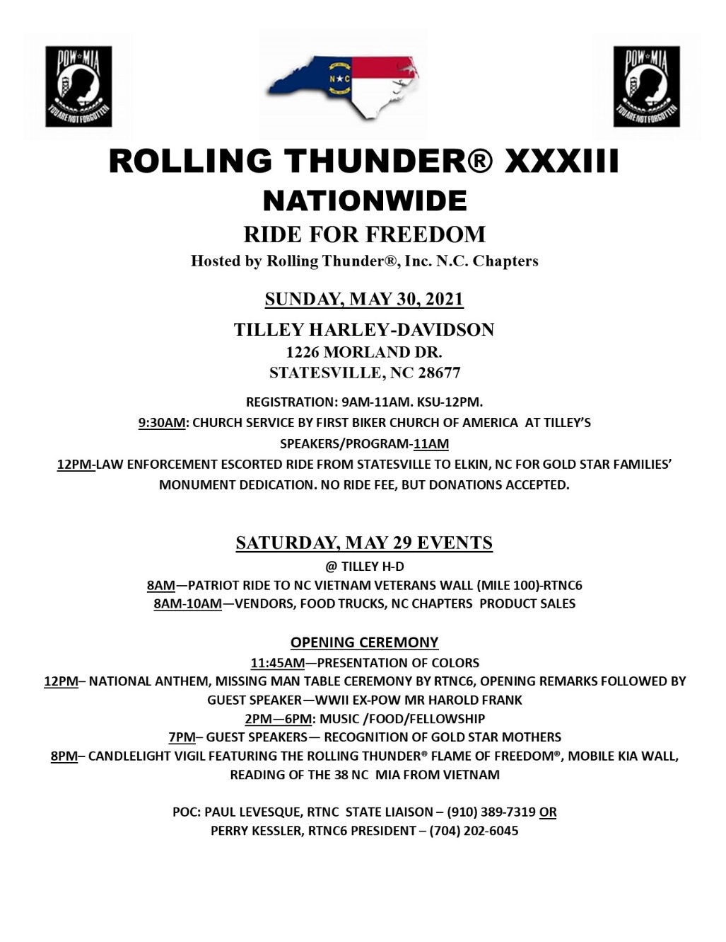

See our Website www.rollingthunder1.com for flyers and additional information

